# *TOP 10 FOOD FOR HELTH*

1. Water

Drink 8 to 12 cups of water daily.

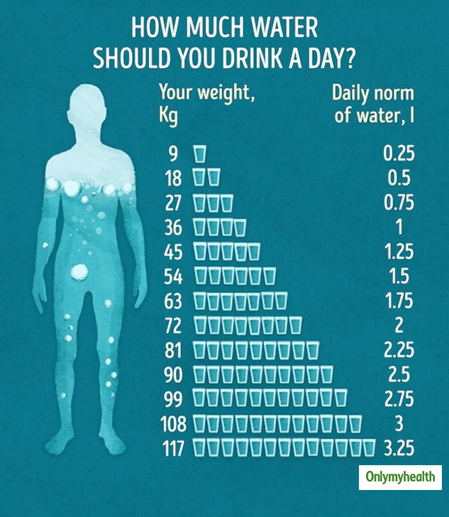

2. Dark Green Vegetables

Eat dark green vegetables at least three to four times a week. Good options include broccoli, peppers, brussel sprouts and leafy greens like kale and spinach.

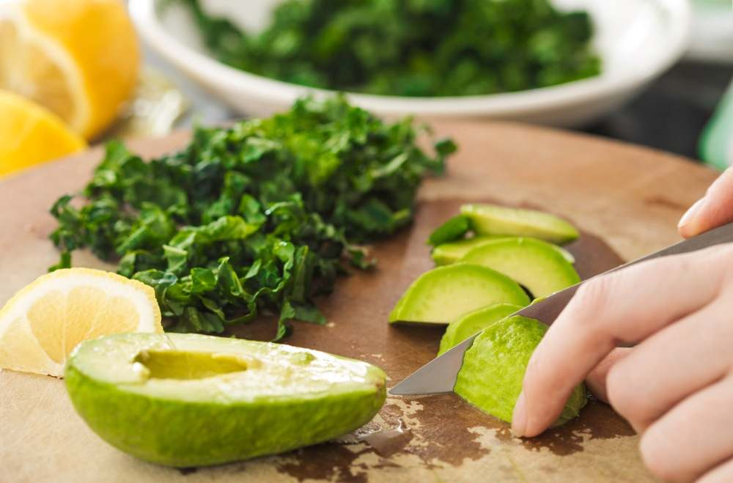

3. Whole Grains

Eat whole grains sat least two or three times daily. Look for whole wheat flour, rye, oatmeal, barley, amaranth, quinoa or a multigrain. A good source of [fiber](https://www.ucsfhealth.org/education/increasing-fiber-intake) has 3 to 4 grams of fiber per serving. A great source has 5 or more grams of fiber per serving.

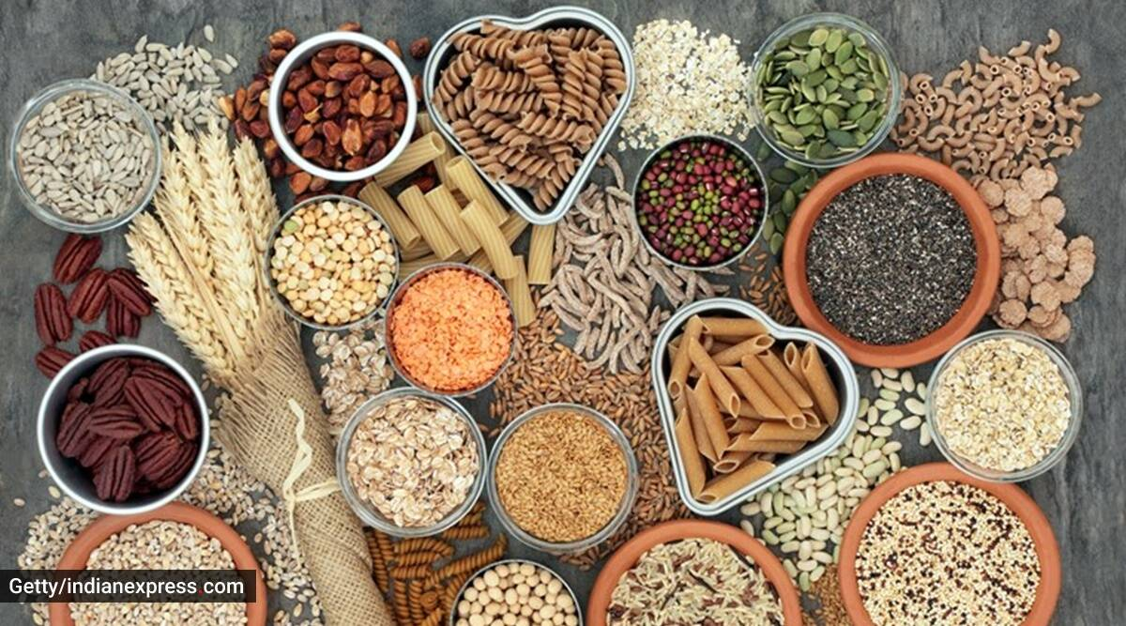

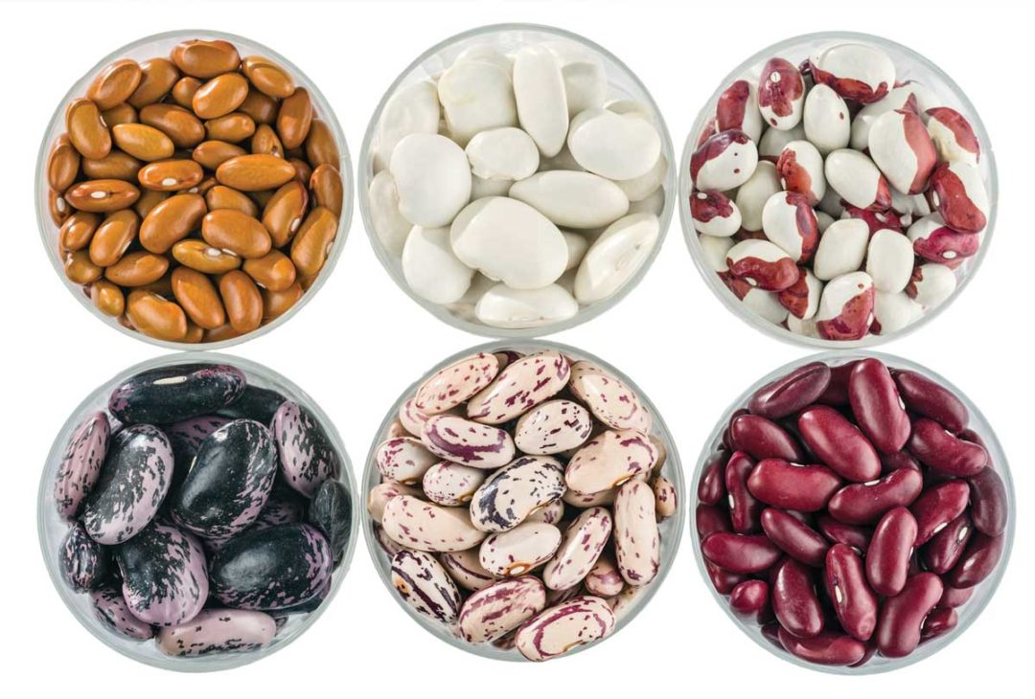4. Beans and Lentils

Try to eat a bean-based meal at least once a week. Try to add legumes, including beans and lentils, to soups, stews, casseroles, salads and dips or eat them plain.

5. Fish

Try to eat two to three serving of fish a week. A serving consists of 3 to 4 ounces of cooked fish. Good choices are salmon, trout, herring, bluefish, sardines and tuna.

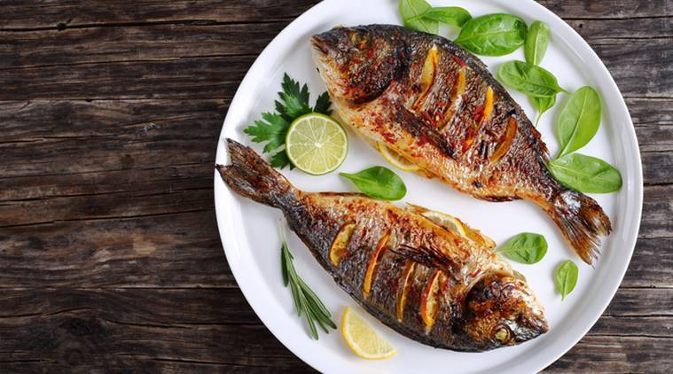

6. Berries

Include two to four servings of fruit in your diet each day. Try to eat berries such as raspberries, blueberries, blackberries and strawberries.

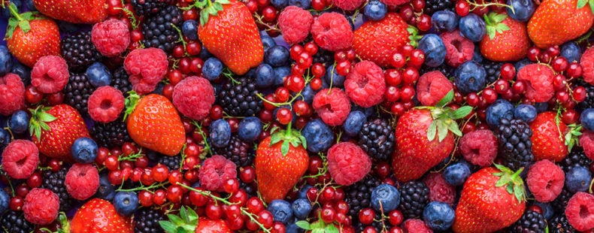

7. Winter Squash

Eat butternut and acorn squash as well as other richly pigmented dark orange and green colored vegetables like sweet potato, cantaloupe and mango.

8. Soy

25 grams of [soy protein](https://www.ucsfhealth.org/education/soy-protein-content-of-foods) a day is recommended as part of a low-fat diet to help lower cholesterol levels. Try tofu, soy milk, edamame soybeans, tempeh and texturized vegetable protein (TVP).

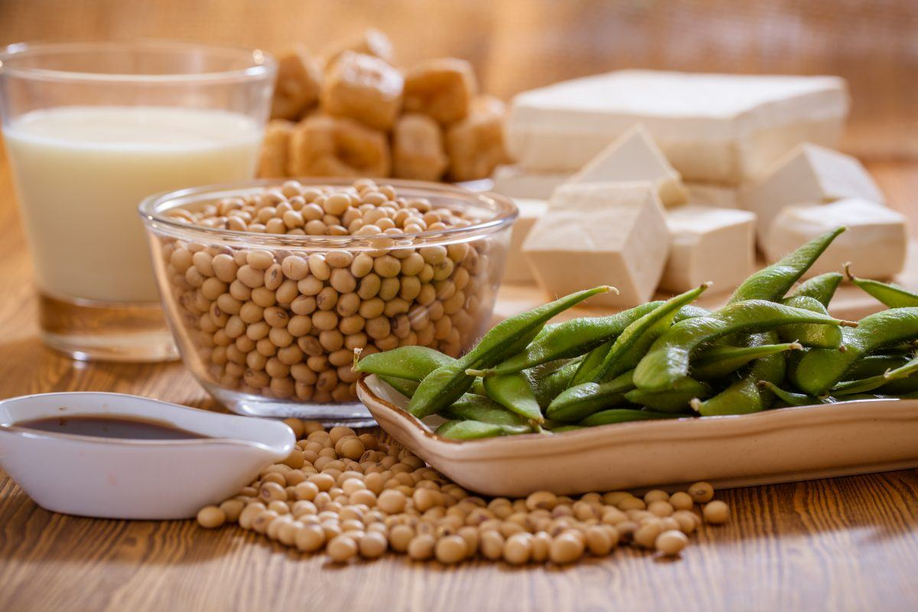

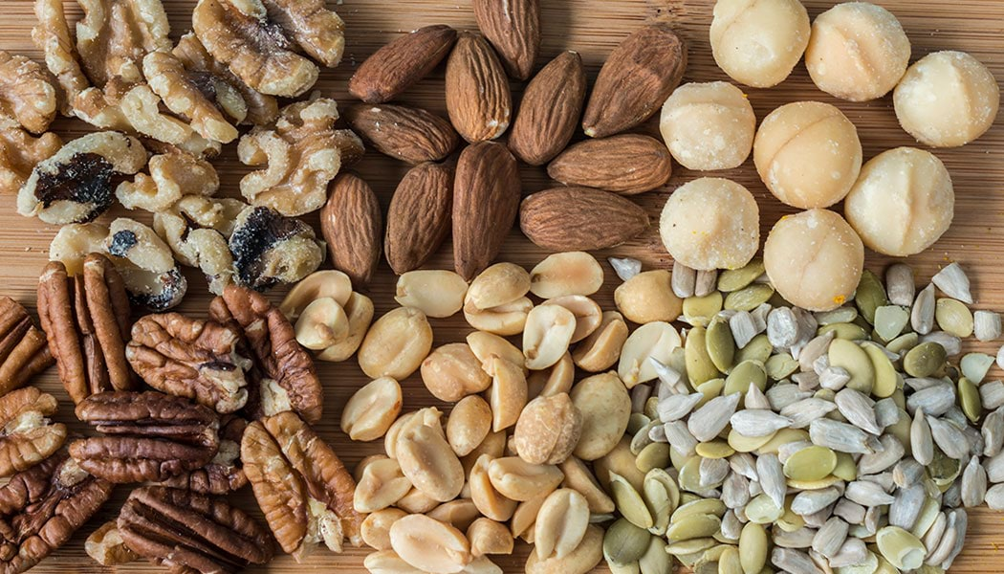9. Flaxseed, Nuts and Seeds

Add 1 to 2 tablespoons of ground flaxseed or other seeds to food each day or include a moderate amount of nuts – 1/4 cup – in your daily diet.

10. Organic Yogurt

Men and women between 19 and 50 years of age need 1000 milligrams of calcium a day and 1200 milligrams if 50 or older. Eat calcium-rich foods such as nonfat or low-fat dairy products three to four times a day. Include organic choice.

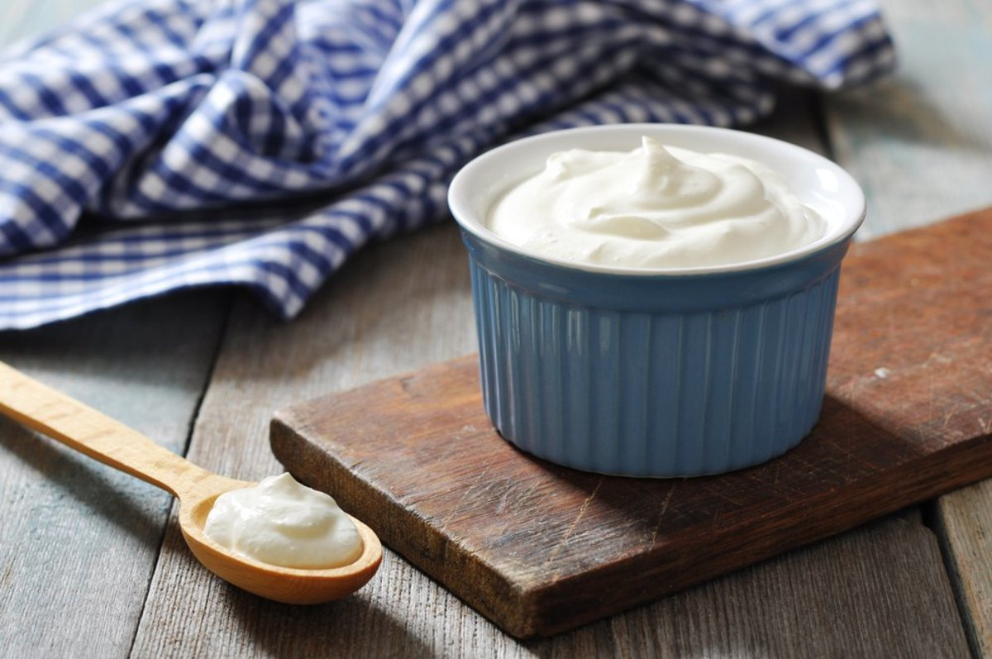

# *HELTH DRINKS*



# Best Choice: Water

## Water is essential for your body. It prevents dehydration, constipation, and kidney stones. Plus, with no calories, it’s the best beverage for your waistline. If you add 1 to 3 cups of water a day to your diet, you could end up taking in less fat, salt, sugar, and up to 200 fewer calories per day. Too plain? Calorie-free flavor drops sweeten, but may have artificial flavors, colors, or preservatives. Try a squeeze of citrus instead.

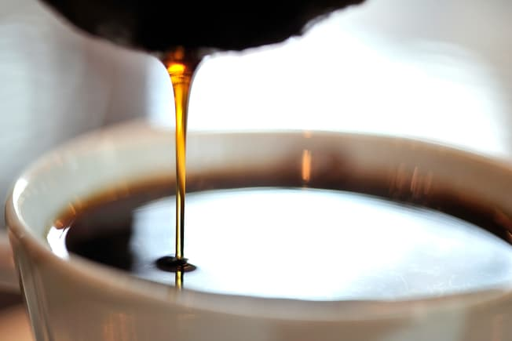

**Best Choice: Filtered Coffee**

Coffee has gotten a bad rap before, but studies show it may protect against type 2 diabetes, liver disease, and lower your odds of heart disease. Three to five cups a day seems to be healthy, as long as you go easy on the cream and sugar. But if you’re pregnant or breastfeeding, ask your doctor how much to sip. If you have high cholesterol, brew yours with a paper filter. It gets rid of a substance called cafestol that can raise LDL cholesterol.



**Best Choice: Tea**

Green, black, and other kinds are full of antioxidants, which may protect you against some types of cancer, stroke, heart disease, and high blood pressure. Plus, unsweetened brews are low in calories. Whether you like it hot or iced, the healthiest kinds are the ones you brew at home -- without the added sugars that bottled tea can have.

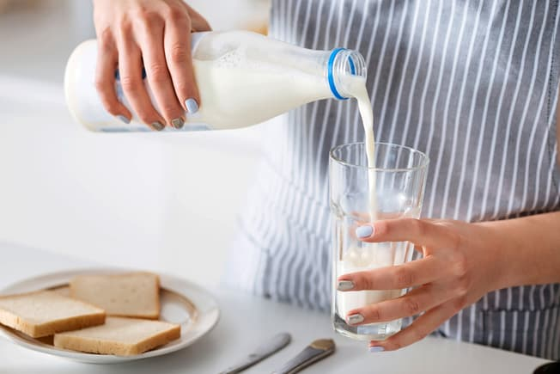

**Good Choice: Milk**

It’s a powerhouse of nutrients like calcium, vitamin D, and potassium, which keep your muscles, teeth, and bones healthy. And a cup of it has more protein than a large egg. To get more nutrition from fewer calories, look for low-fat and skim options. Some nondairy milks -- soy, oat, almond, and others -- have some of the same nutrients as cow’s milk, but the concentration of these is low per serving.

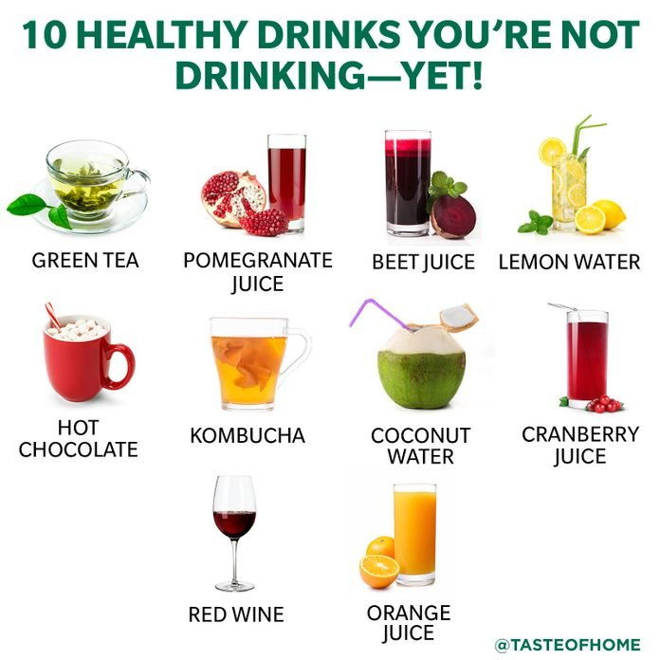SYDNEY WATSON/TASTE OF HOME

With so many drinks filled with empty calories on supermarket shelves, it can be hard to find healthy drinks that also come with vitamins and minerals. But fear not, there are plenty of nutritious [beverages](https://www.tasteofhome.com/recipes/dishes-beverages/beverages/) to quench your thirst if you’re in the mood for something other than plain or [infused water](https://www.tasteofhome.com/article/10-insanely-easy-infused-water-recipes/).

2 / 11

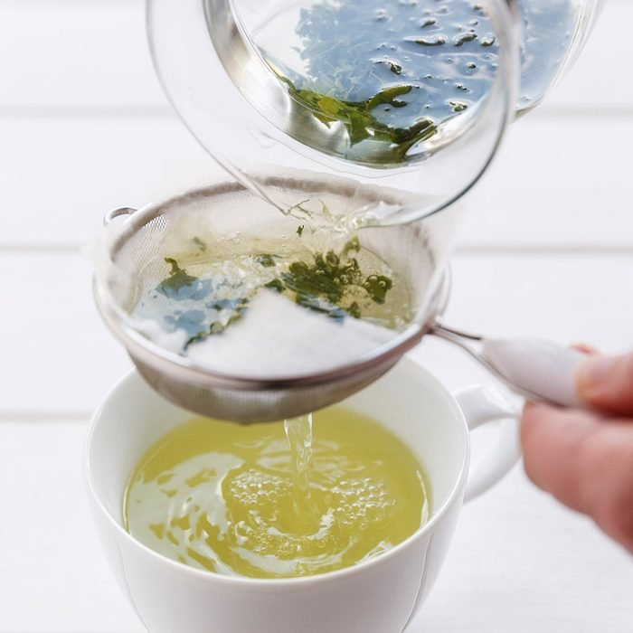WESTEND61/GETTY IMAGES

## ****Green Tea****

[Green tea](https://www.tasteofhome.com/article/is-green-tea-healthy/) has been hailed for its health benefits in Asian countries for centuries; only recently did Americans get the memo. While many know green tea as a healthy drink that hydrates and soothes the soul, this drink does even more good than you may know. Green tea contains a high level of polyphenols which are believed to prevent certain types of cancer like breast cancer and prostate cancer. Studies suggest it can also help reduce sharp increases in blood sugar after a meal, which can be especially beneficial for people with type 2 diabetes. Give this warm and soothing [lemon thyme green tea](https://www.tasteofhome.com/recipes/lemon-thyme-green-tea/) a try.

ADVERTISEMENT

ADVERTISEMENT

3 / 11

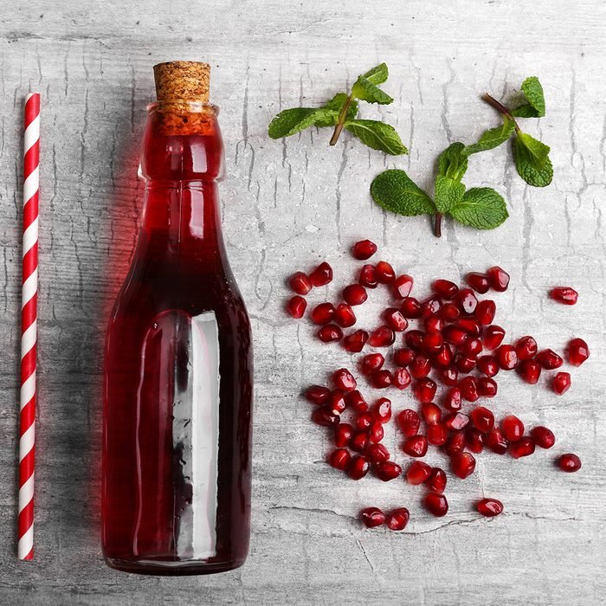AFRICA STUDIO/SHUTTERSTOCK

## ****Pomegranate Juice****

All-natural pomegranate juice is one of the most nutritious beverages on supermarket shelves. This vibrant fruit juice is packed with antioxidants that help protect cells from damage and decrease inflammation, which may help relieve some types of arthritis. It’s also rich in immune-boosting vitamin C, making it one of our favorite healthy drinks to fight off colds. Learn more about the [health benefits of pomegranate](https://www.tasteofhome.com/collection/pomegranate-benefits-for-health-and-beauty/).

4 / 11

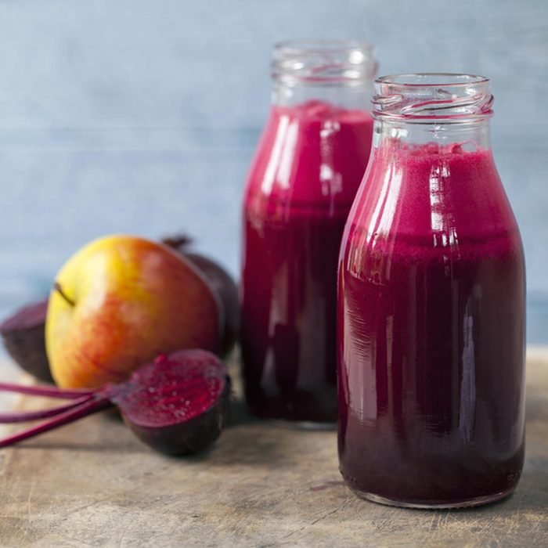MAGDANATKA/SHUTTERSTOCK

## ****Beet Juice****

Need a few reasons why you should incorporate beets into your diet? [Beets’ health benefits](https://www.tasteofhome.com/collection/beets-health-benefits/) are abundant, starting with the fact that they’re a powerful source of folic acid, magnesium and nitrates. Our bodies convert nitrates into nitric oxide, which helps lower blood pressure and improve blood flow. Some studies suggest it’s a great [food to eat before you workout](https://www.tasteofhome.com/collection/best-foods-to-eat-before-a-workout/) to increase stamina. Grab a juicer and make this sweet healthy drink to go.

5 / 11

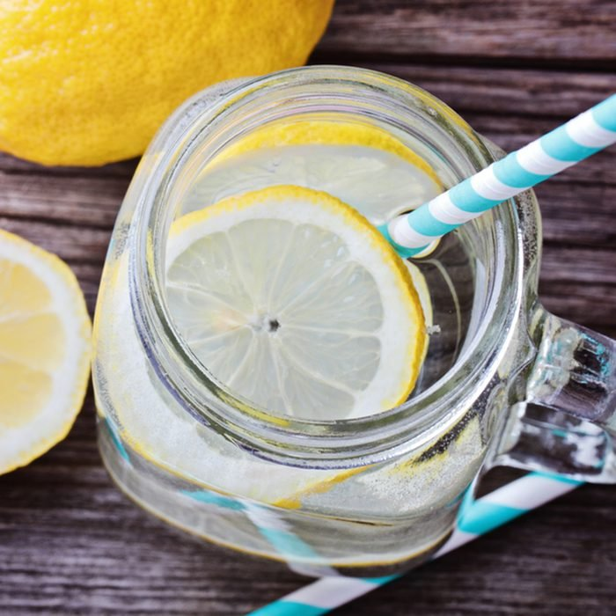TATIANA FRANK/SHUTTERSTOCK

## ****Lemon Water****

We recommend [starting your day with lemon water](https://www.tasteofhome.com/article/why-you-should-start-your-day-with-a-glass-of-lemon-water/). Lemon water is a surprisingly powerful immune booster. Just 2 tablespoons of lemon juice stirred into a glass of water adds 14mg vitamin C. Another bonus? You’ll probably drink more lemon water than plain water because it tastes better—one more way to help stay hydrated.

ADVERTISEMENT

ADVERTISEMENT

6 / 11

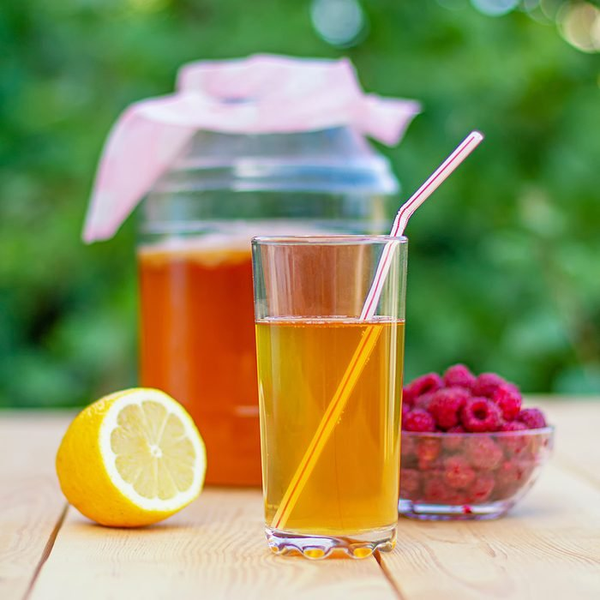SERGEYYREV/SHUTTERSTOCK

## ****Kombucha****

[What is kombucha](https://www.tasteofhome.com/article/what-is-kombucha/), anyway? This elixir is one of the hottest healthy drinks on the market. Wellness junkies rave about [kombucha’s health benefits](https://www.tasteofhome.com/collection/kombucha-health-benefits/). Like other healthy [fermented foods](https://www.tasteofhome.com/article/the-health-benefits-of-fermentation/), fizzy kombucha is packed with probiotics that promote healthy bacteria in the gut. These bacteria aid in digestion and help your body absorb vitamins and minerals. Find out our favorite [kombucha brand](https://www.tasteofhome.com/article/best-kombucha-brands/) from our most recent taste test.

7 / 11

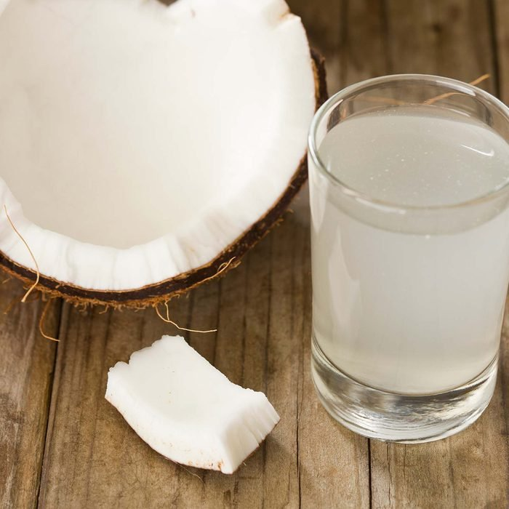DEBBI SMIRNOFF/GETTY IMAGES

## ****Coconut Water****

The flavor of this tropical water is a bit controversial. Some people love it, and some hate it. But there’s no debating the fact that this healthy drink can hydrate the body and provide a surprising amount of potassium. Potassium plays an important role in maintaining a healthy heartbeat and regulating blood pressure. If you like carbonation, try this [sparkling coconut water](https://www.amazon.com/Vita-Coco-Sparkling-Coconut-Grapefruit/dp/B07GDTFTFR/?ots=1&tag=tohmke-20). (It’s one of our favorite [healthy carbonated drinks](https://www.tasteofhome.com/collection/healthy-carbonated-drinks/).)

8 / 11

TASTE OF HOME

## ****Hot Chocolate****

Who knew treats could be nutritious? We’ve all heard about the health benefits of cacao, but this antioxidant-rich drink is even more beneficial when mixed with milk, which is high in calcium and usually fortified with vitamin D. Find a new favorite [hot chocolate recipe](https://www.tasteofhome.com/collection/hot-chocolate-for-the-holidays/) or try one of our [favorite hot chocolate brands](https://www.tasteofhome.com/article/best-hot-chocolate-brand/).

ADVERTISEMENT

ADVERTISEMENT

9 / 11

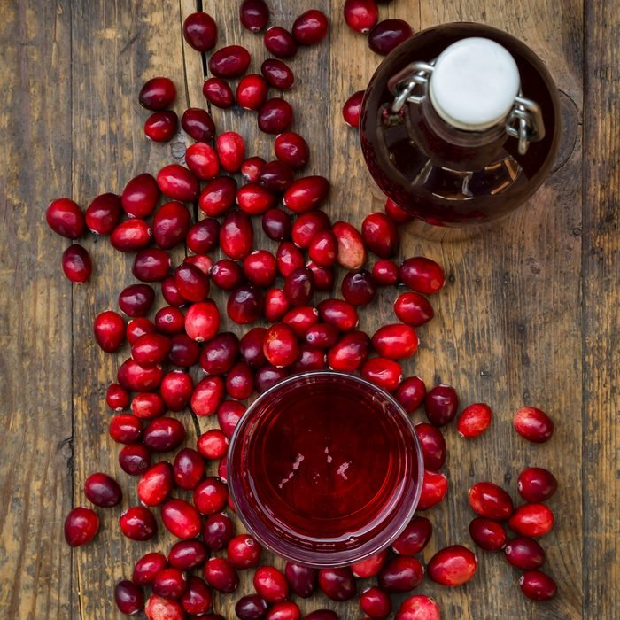WESTEND61/GETTY IMAGES

## ****Cranberry Juice****

This tangy juice is packed with antioxidants that can help prevent cardiovascular disease and some types of cancer, and promotes a healthy urinary tract. Cranberry juice is tart on its own, so it’s combined with sugar or other, sweeter fruit juices. Look for varieties that are 100% juice so you’re taking in all of [cranberries’ health benefits](https://www.tasteofhome.com/collection/cranberry-benefits/).

10 / 11

NATALIA VAN DONINCK/SHUTTERSTOCK

## ****Red Wine****

Thought red wine was only good for kicking back and relaxing? Think again. Studies suggest that moderate amounts of any alcohol can help increase HDL (good cholesterol) and prevent artery damage. Resveratrol is an antioxidant specifically found in red wine that might have even more health benefits like helping to decrease LDL (bad cholesterol) and prevent blood clots. Red wine may even improve your oral health, too! Try a glass a day or switch things up with a warming glass of [mulled red wine](https://www.tasteofhome.com/recipes/mulled-red-wine/).

11 / 11

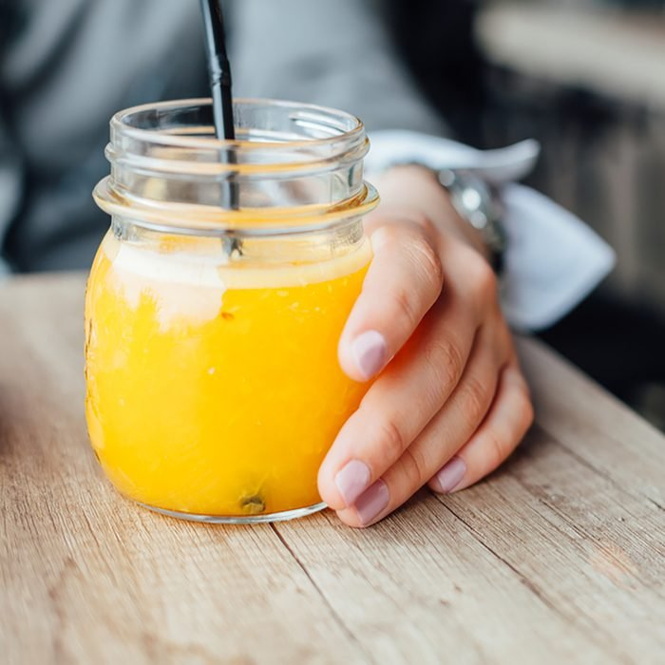KIKOVIC/SHUTTERSTOCK

## ****Orange Juice****

Possibly the most ubiquitous juice on the market, fresh orange juice is one of the [healthiest drinks](https://www.tasteofhome.com/collection/your-body-on-orange-juice/) you can grab. Everybody knows it’s a great source of vitamin C, but most people don’t know that this healthy drink is a good source of potassium and thiamin plus calcium and vitamin D if it’s fortified. If you find fizz refreshing, try it in an [orange juice spritzer](https://www.tasteofhome.com/recipes/orange-juice-spritzer/).